## Current Activities

Hursley site finally reopened in March. No mandatory masks or social distancing, but they have made available badge lanyards in red, yellow and green – from keep away to come closer! There has not been a mad rush back to office desks, and we curators are also taking things slowly. We do have a lot of tidying up to do; lots of donations have been piled up in our absence, which all need sorting out. We have received a shipment of four boxes of manuals from St. Andrews University, mainly going back to their IBM S/360 model 44 (developed in Hursley) and 1620 systems.

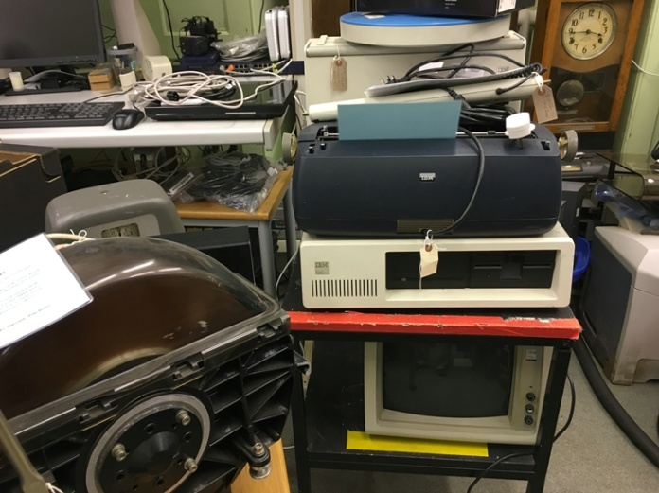 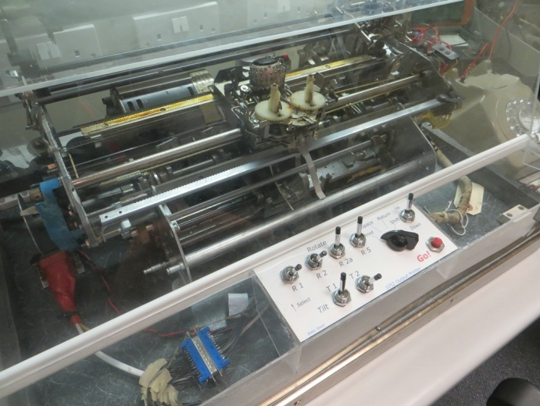

Hardware everywhere 1052 golf ball console printer

Our first venture into the museum saw some checks on hardware that was working OK 2 years ago. Our 029 card punch was a bit sluggish, increased friction causing the main drive belt to slip (it has stretched and needs replacing, but we can’t get one anywhere) but once the friction clutch warmed up it began to behave itself. We have an 026 not on display with a reasonable belt, so one of the next jobs is to do a swap.

The 1052 golf ball printer was also not too happy, hesitating during printing and stopping during carriage return. That has now been fixed. The print problem was caused by the cycle shaft contacts contaminated with grease. This was always a favourite fault on S/360 console printers back in the day. Carriage return was more grease in the wrong place on the operational shaft CR spring, as well as a rather weak spring on the op shaft slip clutch causing a lot of slipping. The carriage was also “chattering” when moving in both directions due to a very slightly distorted print shaft.

Several PCs and PS/2s were also in need of attention, and most are now back up and running.

We have also started sorting through hardware where we have more than two examples, and moving the excess into a ‘for disposal’ area to create more space for new and unique donations. Another job, now completed, was to catch up on photographs of hardware that was catalogued 2 years ago but we were excluded from the museum before photos could be processed.

Our 080 card sorter was shipped on schedule to Bletchley Park. We had to order a new toughened glass lid from a local supplier to replace the one broken during transit from Oslo. Our own small stock of these glass panels are from a different model sorter, perhaps a 101 statistical sorter, which fit correctly width-wise but are too deep and protrude out the front, preventing the lid from closing.

The sorter, together with a Hollerith hand punch, is now on display in the new [“The Intelligence Factory”](https://bletchleypark.org.uk/event/the-intelligence-factory/) exhibition. Also a feature in the same room is a sound recording made by our colleagues in Böblingen of one of their working card sorters.

The whole display is extremely impressive and well worth a visit. The punch cards flying above the sorter are a reminder of the VE day celebrations, when staff threw large quantities of cards in the air before being reminded to get back to work. You’d think flying punch cards might be a problem, but pretty well every card that had been through the punch / verify / sort / collate / tabulate process was then destroyed.

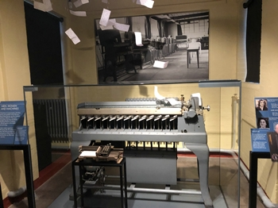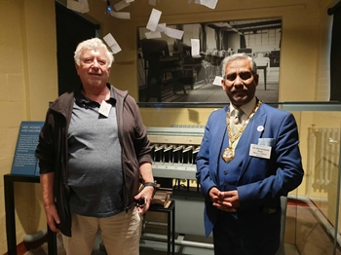

Two representatives from Hursley attended the VIP opening ceremony on the evening of the 26th April – Peter Short and Dave Key. That’s not Dave with Peter but the Mayor of Milton Keynes!

We are also thinking about a complementary display in the museum to reflect the Bletchley exhibition. This will probably include our 416 tabulator and our second 077 collator. These would be complemented by photographs and text panels telling the largely unknown story of the data processing operation behind the code breaking.

Our [museum YouTube channel](https://www.youtube.com/channel/UCX00VSgR9Ul9pvayqc5loqA/videos) is proving to be very popular, particularly the video of our 1052 in slo-mo with 2.1 million views!